KPI pour le secteur logistique

**1.Taux de livraison** :

WITH no_shipped AS (

SELECT COUNT(*)

FROM orders

WHERE `status` != 'Shipped'

),

shipped AS (

SELECT SUM(shippedDate)

FROM orders

WHERE `status` = 'Shipped'

)

SELECT orderNumber,

orderDate,

requiredDate,

shippedDate,

`status`,

comments,

shippedDate-requiredDate AS delais,

sum(quantityOrdered*priceEach)

FROM orders

JOIN orderdetails USING (orderNumber)

WHERE `status` != 'Shipped'

GROUP BY orderNumber, orderDate, shippedDate, `status`, comments, delais;

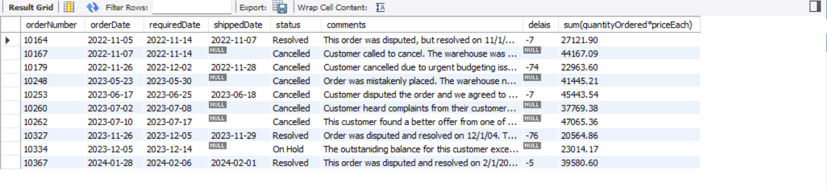

**2. Le ratio du stock 2023**

WITH stock2023 AS (

SELECT productName,

quantityInstock AS stock_act,

round(quantityinstock * 365 / sum(quantityOrdered) ) as ratio_stock,

sum(quantityOrdered) as total_ordered_each_product2023

FROM products

INNER JOIN orderdetails USING(productcode)

INNER JOIN orders USING (orderNumber)

WHERE orderDate BETWEEN '2023-03-04' AND '2024-03-04'

GROUP BY productName,quantityInstock

),

Inventory_value AS (

SELECT productName,quantityInstock*buyprice AS value_stock

FROM products

)

SELECT

stock2023.*,

Inventory_value.value_stock

FROM stock2023

JOIN Inventory_value USING (productName)

ORDER BY stock_act;

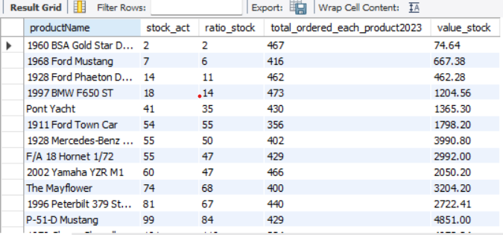

SELECT SUM(quantityinstock)

from products;

stock total

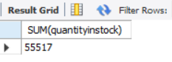

SELECT SUM(quantityInStock * buyPrice) AS stock

FROM products;

le coût du stock total

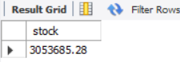

SELECT sum(quantityOrdered * priceEach) as total_ordered_each_product2023

FROM orderdetails

INNER JOIN orders USING (orderNumber)

WHERE orderDate BETWEEN '2023-01-01' AND '2023-12-31';

le CA du 2023

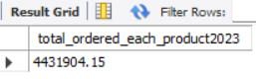

Donc le stock de le coût du stock actuel est 3053685.28 euros qui est représenté 31% de CA du 2023.

**3.CA par office par pays**

WITH country_employee AS (

SELECT lastname, firstname,officeCode, jobtitle, city, country, employeeNumber

FROM employees

INNER JOIN offices USING (officecode)

),

ca_2023 AS (

SELECT customerName, city, country,salesRepEmployeeNumber, sum(quantityOrdered*priceEach) AS ca

FROM customers

JOIN orders USING(customerNumber)

JOIN orderdetails USING(orderNumber)

GROUP BY customerName, city, country,salesRepEmployeeNumber

ORDER BY customerName

)

SELECT country_employee.lastname, country_employee.firstname, country_employee.officeCode, country_employee.jobtitle, country_employee.city, country_employee.country,

ca_2023.ca

FROM country_employee

INNER JOIN ca_2023 ON country_employee.employeeNumber=ca_2023.salesRepEmployeeNumber

ORDER BY ca DESC, country_employee.country;

